Isabela WIBI prototype and evidence package
  - Adviser review draft prepared for Renato Folledo Jr.
Regular PhD in Environmental Science
University of the Philippines Los Baños

Purpose and principal finding
This package presents a working local research application and a consolidated comparison of Lawin, Mangkhut and Egay. It supports discussion of a feasible amendment to the original typhoon flooding index proposal. The principal empirical finding is that rainfall source choice materially changes estimated exposure and can reverse an illustrative threshold decision. The package does not establish which satellite is more accurate or whether an index predicts crop loss.
The application now connects native rainfall maps, common accumulation windows, dated flood evidence, explicit missingness and scenario rules to a traceable review record. Historical crop boundaries and planting dates remain unresolved. The default evidence guide is rule-based; a separate bounded AI adapter is implemented but has not been exercised against a live model or evaluated for RH3.

What is demonstrable now
Component | Current evidence
Three cyclone cases | Lawin 2016, Mangkhut 2018, Egay 2023
Satellite comparison | 115 native cells per event; 2 to 24 hour windows
Historical flood evidence | Partial Egay POST snapshot; other cases unqualified
Reviewable application | Maps, scenario rules, intake preview and JSON export
Scientific status | Descriptive evidence and verified software behaviours

Decision requested from the adviser
Review whether the amended dissertation may centre on environmental evidence qualification, source and index sensitivity, and controlled AI-assisted review, while deferring unsupported farm-loss calibration and actuarial claims. This is a substantive amendment to the original depth, stream-gauge and yield-loss validation commitments, not a declaration that those commitments have been fulfilled.
The prototype is a concrete milestone for the December discussion. Dissertation acceptance and publication sufficiency remain decisions for the adviser and committee.

Rainfall source differences across the three cases
Both products use the same selected interval and geographic Isabela area weights within each comparison. The interval maximizes the equally weighted mean of the two provincial estimates. These retrospective pooled maxima are exploratory and must not be presented as the prespecified six-hour RH2 timing rule. Values are rainfall depths in millimetres, not rice-specific or parcel-level exposure.
Cyclone | Hours | IMERG | GSMaP | Difference
Lawin | 6 | 89.4 | 95.4 | +6.0
Lawin | 24 | 158.4 | 226.5 | +68.1
Mangkhut | 6 | 69.1 | 119.6 | +50.5
Mangkhut | 24 | 150.9 | 260.3 | +109.4
Egay | 6 | 25.1 | 65.3 | +40.2
Egay | 24 | 78.7 | 181.0 | +102.3

Difference is GSMaP minus IMERG. The complete seven-duration tables and precise UTC intervals are in results/THREE_EVENT_RAINFALL.csv. Mangkhut and Egay reuse the latest R outputs. Lawin was packaged from its existing R-generated hourly cache using the same descriptive selection rule in Python; R was not executed.

A decision can change with the rainfall source
For Egay, the selected 24-hour provincial means are 78.7 mm for IMERG and 181.0 mm for GSMaP. A hypothetical 150 mm rainfall-only threshold would be not exceeded under IMERG and exceeded under GSMaP. This demonstrates source sensitivity. The threshold is an illustrative teaching value, not a calibrated crop-damage threshold or an insurance contract.

Different cached periods remain explicit
Lawin covers 48 hours from 19 October to 21 October 2016 PHT, with the end exclusive. Mangkhut and Egay each cover 168 hours. Their full-period totals therefore are not equivalent-duration event metrics. Rainfall in these periods may include other weather influences; all rain is not automatically attributed to the named cyclone.

Ground records remain under review
The latest audit inspected 388 precipitation fields: 276 matched original SYNOP amounts but retained accumulation flags; 77 matched amounts but retained provider-QC concerns; 23 represented trace rainfall numerically as zero; 10 contained conflicting decoded groups; and two were missing or malformed. SYNOP and AA fields are representations of the same report. Agreement is not independent gauge validation, and no audited field was automatically approved as a reference.

Spatial patterns differ as well as totals
The paired 24-hour figures use a common colour scale within each event. They show native 0.1-degree rainfall estimates clipped to the administrative footprint; they do not create farm-scale rainfall information.
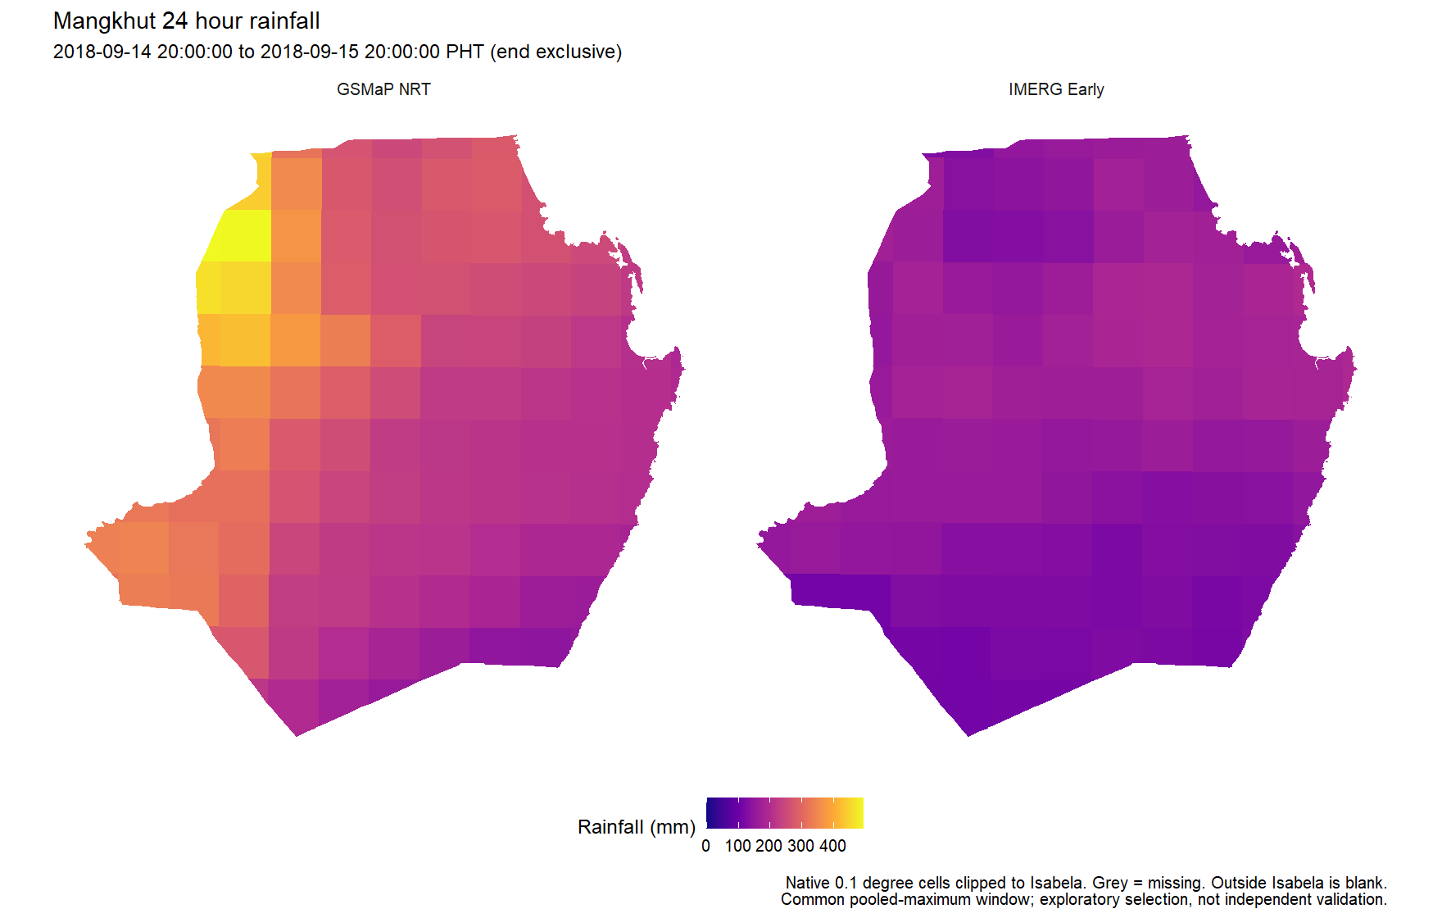
Mangkhut: GSMaP places its strongest rainfall in western and northwestern cells; IMERG maxima are farther east.
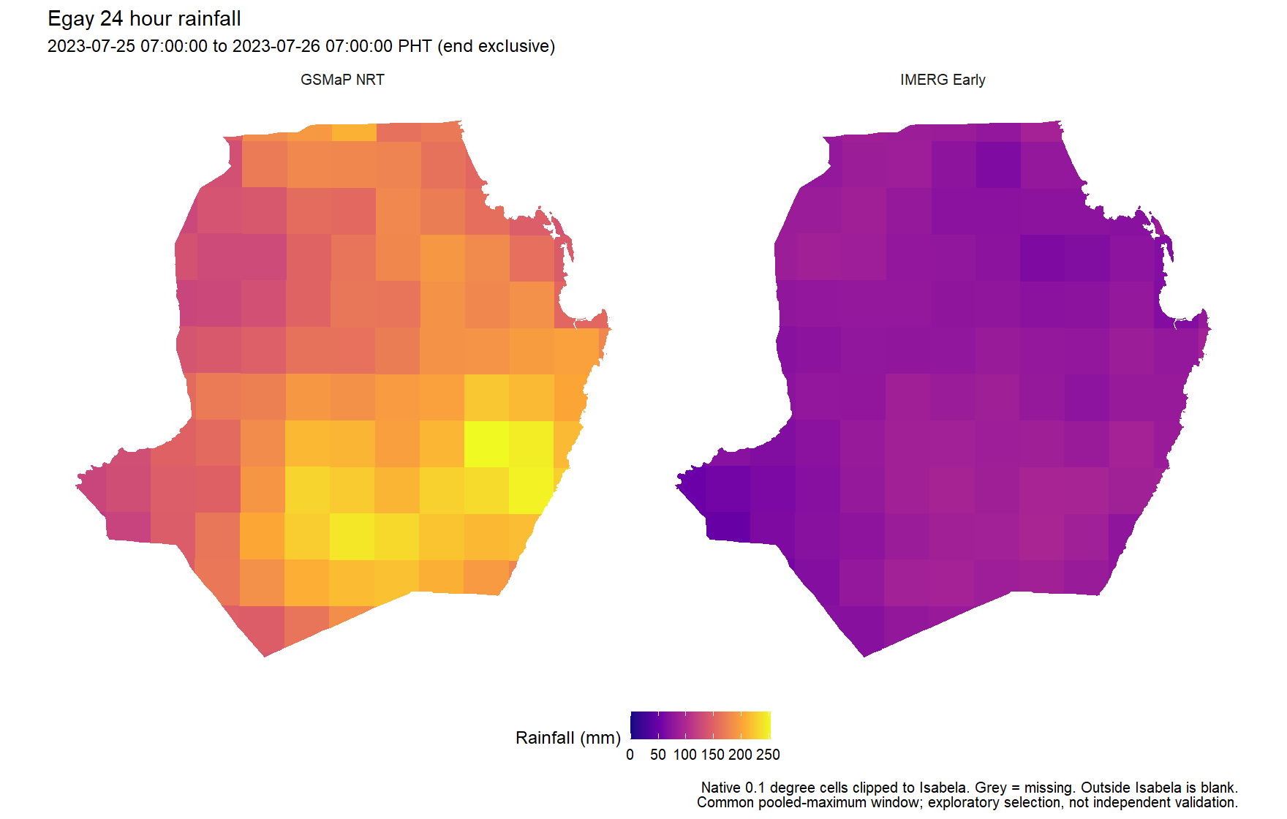
Egay: both products show relatively wetter southern areas, but GSMaP estimates substantially larger rainfall.

Flood evidence and the prototype design
The Egay image was acquired on 29 July 2023 at 05:46:26 PHT, after the selected 25 to 26 July rainfall peak. Strictly observed coverage was 15.7% of the packaged provincial footprint. The audit detected 7.832 hectares of flooding in two native rainfall cells, within 161,280.969 hectares of strictly observed area. These hectares are not necessarily rice, insured land or maximum event flooding.
For those two flood-positive cells, preceding 120-hour rainfall was about 169 to 182 mm under IMERG and 385 to 386 mm under GSMaP. Preceding 24-hour rainfall was only 2.2 to 7.6 mm across the products. Antecedent totals end at the last full hour before acquisition, leaving a documented 46.43-minute lag. The timing motivates longer-window review but does not establish rainfall causation, flood duration, upstream routing or loss.

Application components
Component | Implemented behaviour
Evidence package | Pinned source reports, cell totals, timestamps and hashes
Deterministic rules | Rainfall, flood, OR and AND with explicit unknown states
Parcel intake | Local polygon preview; no qualified parcel overlay
Crop stage | Unknown or labelled scenario context; no loss multiplier
Evidence assistant | Offline guide plus optional read-only AI tool adapter
Review export | Thresholds, evidence mode, source IDs and review state

A minimum flood-observation coverage rule prevents a partial image from silently becoming a no-flood decision. OR and AND use explicit three-valued logic: a known branch can determine a logical result, but the unresolved branch and review requirement remain recorded. No application result authorizes payment.

AI boundaries
The optional agent can read only fixed evidence tools and a server-recomputed trigger review. It cannot access arbitrary files, execute commands, modify thresholds or approve payment. Its source citations must refer to inspected evidence. These controls do not prove that generated prose is correct; live-model testing and independent scoring remain necessary. API access is optional and requires local credentials and an explicit model choice.

Three papers and the remaining research decisions

Paper 1 Dated rice exposure
Retain RH1 from the Rice Aligned proposal: test whether the event-level difference in newly inundated rice share is zero when dated and static rice masks are compared on the same valid geographic denominator. The current package cannot test RH1 because qualified paired rice masks and matched flood evidence are missing. Parcel demonstrations cannot replace these data. Agree an access deadline and an explicit methodological amendment if the empirical input pair cannot be secured.

Paper 2 Rainfall source and index sensitivity
Retain RH2: test the mean event-level IMERG Early versus GSMaP NRT difference for a prespecified six-hour provincial accumulation and fixed common mask. The current cases provide descriptive feasibility and sensitivity results. All three have been inspected; they cannot now be called untouched evaluation episodes. Pixels, durations and overlapping windows do not increase the independent storm count. Additional qualifying episodes and a frozen timing rule are needed for confirmatory inference.

Paper 3 Constrained AI evidence review
Retain RH3: test whether constrained iterative read-only tool use improves fully correct evidence-supported task resolution compared with a matched single-pass assistant. The prototype supplies both adapter modes, but the research experiment remains unexecuted. Freeze the model, evidence universe, resource budget, task families and scoring before held-out testing. Repeated seeds are nested observations, and passed software tests are not a measure of AI benefit.

Proposed milestones for adviser discussion
Working target | Deliverable
6 November | Freeze evidence register and explicit RH1 access decision
13 November | Review this working prototype and essential refinements
20 November | Submit adviser brief and approved evaluation plans
December | Demonstrate the system and agreed bounded contribution

These are working targets, not scheduled autonomous tasks or guarantees. Three-paper feasibility depends on the committee accepting the scope and on resolving the empirical exposure dependency. Unavailable tests should remain untested. Retain the proposal’s multiplicity plan when primary tests are actually estimable; do not replace missing results with favourable exploratory comparisons.

Verification and meeting demonstration
At preparation, 709 JavaScript checks and 11 Python tests passed in their recorded invocations. They cover missingness, OR/AND truth tables, threshold boundaries, known source disagreement, parcel intake safeguards, browser/server numerical parity over 168 scenarios, source preservation and mocked AI tool restrictions. No R or live AI calls were executed. Browser and document layout checks are recorded separately in results/QA_REPORT.txt.

Suggested meeting sequence
- Show Egay at 24 hours and compare the two rainfall maps and provincial means.
- Apply the illustrative 150 mm rainfall threshold and show the source-dependent result.
- Switch to flood only and show why insufficient observation coverage remains unassessable.
- Activate the explicitly synthetic flood scenario and compare OR with AND.
- Show unassessed parcel intake, unknown stage and the evidence assistant’s limits.
- Export the review record and discuss the three remaining hypothesis dependencies.

Package and source register
Open Open_WIBI_Prototype.cmd in this package, or dist/index.html for the offline viewer. See README.txt for optional AI setup, DEMONSTRATION.txt for the meeting sequence, and RH3_EVALUATION_PROTOCOL.txt for the proposed evaluation design. The authoritative source paths and SHA-256 values are in results/SOURCE_MANIFEST.csv.
Rice Aligned proposal dated 20 October 2026, sections RH1 to RH3; working flood, rainfall and rice-stage amendment dated 28 October 2026.
Lawin zone assessment run 20261023T071006PHT_820 and its generated hourly native-cell cache.
Coverage and ground qualification run 20261030T180136PHT_820.
Evidence analysis run 20261030T185440PHT_820, including selected windows, source-message audit and antecedent flood comparison.
Flood/rice discovery run 20261028T200852PHT_820; parcel review run 20261028T222139PHT_820; corrected AWS comparison run 20261028T001723PHT_17592.
This brief reports generated local evidence and proposed research decisions. It does not add unverified literature or revise the approved proposal by itself.

